NEWS TRACKER APPLICATION USING CLOUD
A Project Report submitted in Partial fulfilment of 7th Semester in degree of
BACHELOR OF ENGINEERING
IN
COMPUTER SCIENCE ENGINEERING
Submitted by
Team ID : PNT2022TMID45371
SHANMUGAPRIYA.M
SIVANANTHA KARTHIKA.B
VIJAYALAKSHMI.D
JEEVITHA.S

M.I.E.T ENGINEERING COLLEGE OF ENGINEERING ,TRICHY-7

BONAFIDE CERTIFICATE
Certified that this project report “NEWS TRACKER APPLICATION” is the Bonafide Record work done by SHANMUGAPRIYA.M(812419104308), VIJALAKSHMI.C (812419104073), SIVANANTHA KARTHIKA(812419104064), JEEVITHA.S(812419104303), for IBM NALAYATHIRAN in VII Semester of B.E.., degree course in Computer Science Engineering Branch during the Academic year of 2022-2023.

2
ABSTRACT
Everyone has the right to freedom of speech. However, this right is being misused to differentiate and attack others, physically or verbally, in the name of free speech. This discrimination is known as hate speech. Hate speech can be well-defined as language used to express hate towards a person or a group of people based on characteristics such as race, religion, ethnicity, gender, nationality, disability and sexual orientation. The increasing usage of social sites and information sharing has specified major benefits to humanity. However, this has also assumed rise to a variety of challenges including the spreading and sharing of hate speech messages. Thus, to solve this emerging issue in social media sites, recent studies employed a variety of machine learning and deep learning algorithms with text mining algorithm to automatically detect the hate speech messages on real time datasets. Hence, the aim of this Project is to analyses the comments on social networks using Natural Language processing technique (NLP) and Deep learning algorithm named as Back propagation neural network algorithm. Using NLP technique, can extract the keywords from user generated content and implement Back Propagation neural network to classify the text whether it is positive or negative. If it is negative means, automatically block the comments as per user wish and also block the friends based on pre-defined threshold values. Experimental results shows that the proposed framework implemented in real time social network site with improved notification.
3
TABLE OF CONTENTS
1. INTRODUCTION
1.1 Project Overview
1.2 Purpose
2. LITERATURE SURVEY
2.1 Existing problem
2.2 References
2.3 Problem Statement Definition
3. IDEATION & PROPOSED SOLUTION
3.1 Empathy Map Canvas
3.2 Ideation & Brainstorming
3.3 Proposed Solution
3.4 Problem Solution fit
4. REQUIREMENT ANALYSIS
4.1 Functional requirement
4.2 Non-Functional requirements
5. PROJECT DESIGN
5.1 Data Flow Diagrams
5.2 Solution & Technical Architecture
5.3 User Stories
6. PROJECT PLANNING & SCHEDULING
6.1 Sprint Planning & Estimation
6.2 Sprint Delivery Schedule
6.3 Reports from JIRA
7. CODING & SOLUTIONING (Explain the features added in the project along with code) 7.1 Feature 1
7.2 Feature 2
7.3 Database Schema (if Applicable)
8. TESTING
8.1 Test Cases
8.2 User Acceptance Testing
9. RESULTS
9.1 Performance Metrics
10. ADVANTAGES & DISADVANTAGES
11. CONCLUSION
12. FUTURE SCOPE
13. APPENDIX Source Code GitHub & Project demo
4
1.INTRODUCTION
Mobile app ecosystems are transforming patterns of news consumption. Until quite recently, reading the news was a niche use for smartphones, mostly for when users were ‘on the go’; now however, two in every three users of mobile devices in the US regularly access news and as many as one in five read in-depth news articles daily;
a similar picture is found in the U K. This growth in mobile news access continues the migration of news consumers to the Internet.
1.1 PROJECT OVERVIEW:
As news is increasingly accessed on smartphones and tablets, the need for personalising news app interactions is apparent. We report a series of three studies addressing key issues in the development of adaptive news app interfaces. We first surveyed users ‘news reading preferences and behaviours; analysis revealed three primary types of reader. We then implemented and deployed an Android news app that logs users’ interactions with the app. We used the logs to train a classifier and showed that it is able to reliably recognise a user according to their reader type.
Finally, we evaluated alternative, adaptive user interfaces for each reader type. The evaluation demonstrates the differential benefit of the adaptation for different users of the news app and the feasibility of adaptive interfaces for news apps.
1.2Purpose:
Newspapers are one of the most popular and most needed commodities in our daily life. In today's busy world, reading newspapers has become one of the traditional ways of getting news. News is produced every minute and distributed via television, radio and the Internet, so the news updated the next morning is already outdated. So, newspaper and magazine publishers have a hard time keeping up with the pace. Change is needed and publishers must embrace mobile.
2.LITERATURE SURVEY
2.1References:
Like articles, websites, blogs. https://www.researchgate.net/.
https://techvidvan.com/tutorials/android-news-app-project-source-code/ https://www.ripublication.com/
5
2.2Problem Statement Definition:
In today’s world we have a lot of work and there is no time to cope up everything in the schedule. So, it is not possible to read the newspaper. By using this application, the user can access the news they are interested and get a quick peek for the day. There are multiple news sharing apps used by a single user and are often spammed with notifications. There is also a lot of fake news which gets shared. A news sharing app wants to help users find relevant and important news easily every day and also understand explicitly that the news is not fake but from proper sources. This news tracker application helps the user to get all information about commodities, sports, technology, education etc. The user can register using their personal details and interacts with the application and save their time. • Creating an app that benefits with the smart news filtering functionality where it allows its users to segregate various news sections, comprising of business, sports, political, international, and more. The users can opt for filters like Breaking News, Most Popular, and more.
3.IDEATION & PROPOSED SOLUTION:
3.1. Empathy Map Canvas:
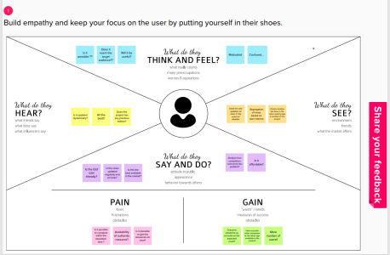6
3.2. Ideation & Brainstorming
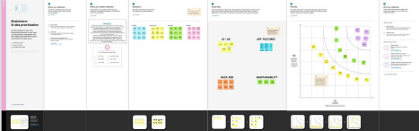
3.3. Proposed Solution
S.NO | PARAMETER | DESCRIPTION
1. | Problem Statement  (Problem to be solved) | The user needs a way to get relevant news based on his choices so that the user does not have to spend a lot of time on searching news. News is filled with ads and spams annoys and irritates the user and affects the user experience.
2. | Idea  solution/Description | A cloud-based web application which enables the user to get the news as per their interests, choices and location. News will be filtered as per the user’s wish and it will be displayed to the user
3. | Novelty/Uniqueness | This news tracker has features that enables the user to view news about crimes and health updates happening in and around their location. This will be given the most  priority as it is important to every person to be aware of recent happenings. The tracker app does not have annoying ads.

7
4. | Social Impact/Customer satisfication | The user will not have to spend a lot of time in searching for the relevant news. The customer will be finally able to view news without ads Since we are using the News API, the news will be reliable and accurate. The customer can be aware of recent happenings.
5. | Business model/  Revenue model | The model will generate revenue through offering few premium features to user. The features include seeing stories from the user’s favourite publishers, regional news, few regional languages. The default language will be English.
6. | Scalablity of the solution | Since the web application is deployed on IBM cloud, it can handle multiple users at a time. The user will go through a seamless experience and it enables them to view the news according to their interests and choices. Users from all age category can use the application and the news can also be filtered according to their age

8
3.4 PROBLEM SOLUTION FIT:

4.REQUIREMENT ANALYSIS
4.1Functional requirement
FR No. | Functional Requirement (Epic) | Sub Requirement (Story / Sub Task)
FR-1 | User Installation | User can install the app from Google play store or from the website
FR-2 | User Registration | Registration through Form Registration through Gmail
FR-3 | User Confirmation | Confirmation via Email
FR-4 | User Login | User should login the app with the user's name and password

4.2Non-Functional requirements
FR No | Non-Functional Requirement | Description
NFR-1 | Usability | Everyone can understand the process of using the app easily by the commands given in the app
NFR-2 | Security | It is a more secured app. No fake news can be shared.
NFR-3 | Performance | Performance of the app is very great
NFR-4 | Availability | More sub categories are available

10
5.PROJECT DESIGN
5.1Data Flow Diagrams
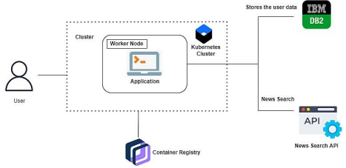5.2. Solution & Technical Architecture
Solution architecture is a complex process – with many subprocesses – that bridges the gap between businessproblems and technology solutions. Its goals are to:
• Find the best tech solution to solve existing business problems.
• Describe the structure, characteristics, behaviour, and other aspects of the software to project stakeholders. • Define features, development phases, and solution requirements to the project.
• Provide specifications according to which the solution is defined, managed, and delivered to the customers.
11
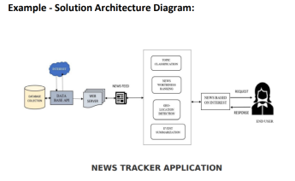
5.3. User Stories:
As our lives are very busy these days, we often feel we need more than 24 hrs. a day to cope up with everything we have in our schedule. Well, that's not possible but reducing the time by changing the conventional method of reading news can help. Just tell us what market news you're interested in and get a quick peek for the day. Only read what you feel is relevant and save your time. This app helps you to query for all information about Indices, Commodities, Currencies, Future Rates, Bonds, etc.… as on
official websites.
12
6.PROJECT PLANNING & SCHEDULING
6.1. Sprint Planning & Estimation:
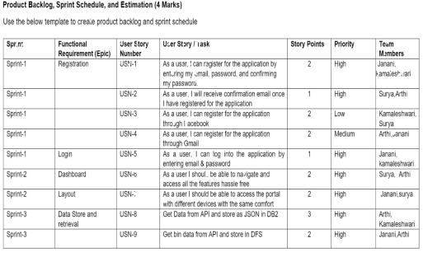
6.2. Sprint Delivery Schedule
Sprint | Total Story Points | Duration | Sprint Start  Date | Sprint End Date (Planned) | Story Points  Completed (as on Planned End  Date) | Sprint Release  Date (Actual)
Sprint-1 | 20 | 6 Days | 9 Nov 2022 | 11 Nov 2022 | 20 | 11 Nov 2022
Sprint-2 | 20 | 6 Days | 11 Nov 2022 | 13Nov 2022 | 20 | 13 Nov 2022
Sprint-3 | 20 | 6 Days | 13 Nov 2022 | 15 Nov 2022 | 20 | 15 Nov 2022
Sprint-4 | 20 | 6 Days | 15 Nov 2022 | 19 Nov 2022 | 20 | 19 Nov 2022

13
6.3. Reports from JIRA
Sprit-1
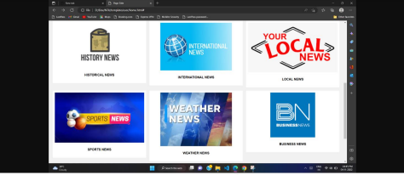
Sprint-2
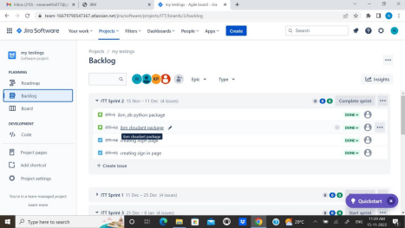
14
Sprint-3
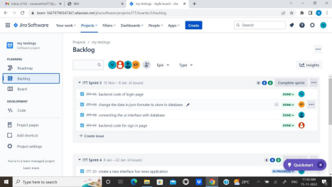
Sprint-4
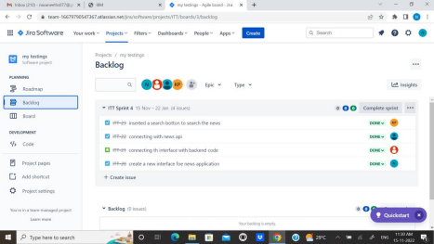15
7.CODING & SOLUTIONING
7.1Feature 1:
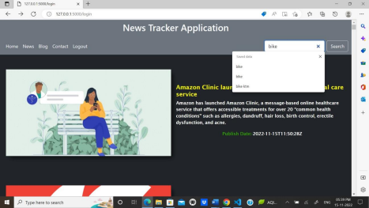7.2 Feature 2:
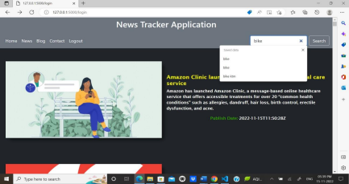16
7.3 Database Schema:
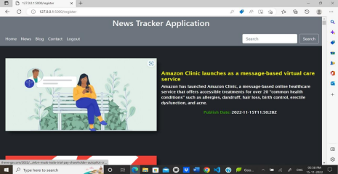17
8.TESTING
8.1. User Test case:
18
8.2 User Acceptance Testing:
19
9.RESULTS
9.1Performance Metrics:
20
21
10.ADVANTAGES
1. All trending news will be displayed in an orderly manner.
2. We can customize the topic which we are interested and make them display.
3.The user experience are quite simple and friendly.
10.DISADVANTAGES
1. Same news which is published in different websites can be displayed.
2. Delay response of news API can make the news collapse.
11.CONCLUSION
Thus, the projected using IBM CLOUD is tested, verified and executed successfully.
12.Future scope
In future, we planned to implement this project in large scale which will be helpful and used by all the people.
13.APPENDIX
13.1. Source Code
Home.html
<!DOCTYPE html>
<html lang="en">
<head>
<meta charset="UTF-8">
<meta http-equiv="X-UA-Compatible" content="IE=edge">
<meta name="viewport" content="width=device-width, initial-scale=1.0">
<link rel="stylesheet" href="{{url_for('static', filename='css/style.css')}}">
<link rel="preconnect" href="https://fonts.googleapis.com">
<link rel="icon" href="{{url_for('static', filename='img/logo.png')}}">
<link href="https://fonts.googleapis.com/icon? family=Material +Icons" rel="stylesheet"> <title>{% block title %}{% end block %}</title>
<link href="https://cdn.jsdelivr.net/npm/bootstrap@5.0.2/dist/css/bootstrap.min.css" rel="stylesheet" integrity="sha384-
22
EVSTQN3/azprG1Anm3QDgpJLIm9Nao0Yz1ztcQTwFspd3yD65VohhpuuCOmLASjC" crossorigin="anonymous">
</head> <body>
<nav class="bg-secondary">
<h2 class="logo text-light">News Tracker Application</h2>
<!-- <ul class= "menu">
<li class="nav-items"><a href='/'>Home</a></li>
<li class="nav-items"><a href='/'>News</a></li>
<li class="nav-items"><a href='/'>Blogs</a></li>
<li class="nav-items"><a href='/'>Contact</a></li>
</ul> -->
</nav>
<nav class="navbar navbar-expand-lg bg-secondary">
<div class="container-fluid">
<!-- <h2>News Tracker Application</h2> -->
<!-- <button class="navbar-toggler" type="button" data-bs-toggle="collapse" data bstarget="#navbarSupportedContent" aria-controls="navbarSupportedContent" aria-expanded="false" arialabel="Toggle navigation">
<span class="navbar-toggler-icon"></span>
</button> -->
<div class="collapse navbar-collapse" id="navbarSupportedContent">
<ul class="navbar-nav me-auto mb-2 mb-lg-0">
<li class="nav-item">
<a class="nav-link active text-light" aria-current="page" href="#">Home</a> </li>
<li class="nav-item">
<a class="nav-link text-light" href="#">News</a>
</li>
<li class="nav-item">
<a class="nav-link text-light" href="#">Blog</a>
</li>
<li class="nav-item" role="contact">
<a class="nav-link text-light" href="/contact">Contact</a>
</li>
23
<li class="nav-item" rol="logout" >
<a class="nav-link text-light" href="/">Logout</a>
</li>
</ul>
<form class="d-flex" role="search" action = "/search" method = "post">
<input class="form-control me-2" type="search" placeholder="Search" aria-label="Search" name = "nm">
<button class="btn btn-outline-light" type="submit">Search</button>
</form>
</div>
</div>
</nav>
<section id="main" class="bg-dark">
<!-- <form action = "/search" method = "post">
<p><input type = "text" name = "nm" /></p>
<p><input type = "submit" value = "submit" /></p>
</form> -->
<!-- <div class="banner"><img
src="https://t4.ftcdn.net/jpg/03/37/92/49/360_F_337924964_fF6I0iZkv9lvoIEn71f0OsgawArIPPDu.jpg "> </div> -->
<!-- <div class = "head">TODAY'S TOP HEADLINES</div>
{% for title,desc,img,p_date,url in contents %}
<div class="wrapper">
<div class="item"><a href="{{url}}"><img src="{{img}}"></a></div> <div class = "c-box">
<div class="content"><a href="{{url}}"><h2>{{title}}</h2></a></div>
<div class="content"><a href="{{url}}"><p>{{desc}}</p></a></div>
<div class="content"><p
style="color:rgb(77, 255, 0);">Publish Date:- </p><p>{{p_date}}</p></div> </div>
</div>
{% endfor %} -->
{% for title,desc,img,p_date,url in all %}
<div class="wrapper">
<div class="item"><a href="{{url}}"><img src="{{img}}"></a></div> <div class = "c-box">
<div class="content"><a href="{{url}}"><h2>{{title}}</h2></a></div>
<div class="content"><p>{{desc}}</p></div>
<div class="content"><p style="color:rgb(48, 158, 0);">Publish Date:- </p><p> {{p_date}} </p></div> </div>
24
</div>
{% endfor %}
</section>
<script
src="https://cdn.jsdelivr.net/npm/@popperjs/core@2.9.2/dist/umd/popper.min.js" integrity="sha384- IQsoLXl5PILFhosVNubq5LC7Qb9DXgDA9i+tQ8Zj3iwWAwPtgFTxbJ8NT4GN1R8p" crossorigin="anonymous"></script>
<script src="https://cdn.jsdelivr.net/npm/bootstrap@5.0.2/dist/js/bootstrap.min.js" integrity="sha384cVKIPhGWiC2Al4u+LWgxfKTRIcfu0JTxR+EQDz/bgldoEyl4H0zUF0QKbrJ0EcQF" crossorigin="anonymous"></script>
</body>
</html>
Index.html
<!DOCTYPE html>
<html lang="en" >
<head>
<meta charset="UTF-8">
<title>CodePen - Sign up / Login Form</title>
<link rel="stylesheet" href="{{url_for('static', filename='css/style2.css')}}">
</head>
<body>
<!-- partial:index.partial.html -->
<!DOCTYPE html>
<html>
<head>
<title>Slide Navbar</title>
<link rel="stylesheet" href="{{url_for('static', filename='css/style2.css')}}">
<link href="https://fonts.googleapis.com/css2?family=Jost:wght@500&display=swap" rel="stylesheet"> </head>
<body>
<div class="main">
<input type="checkbox" id="chk" aria-hidden="true">
<div class="signup">
<form action = "/register" method="post">
<label for="chk" aria-hidden="true">Sign up</label>
<input type="text" name="un" placeholder="User name"
required="">
<input type="email" name="ue" placeholder="Email"
required="">
25
<input type="password" name="up" placeholder="Password"
required="">
<button type="submit">Sign up</button>
</form> </div>
<div class="login">
<form action = "/login" method="post">
<label for="chk" aria-hidden="true">Login</label>
<input type="email" name="email" placeholder="Email"
required="">
<input type="password" name="pswd" placeholder="Password"
required="">
<button type="submit">Login</button>
</form>
</div>
</div>
</body>
</html>
<!-- partial -->
</body>
</html>
Contact.html
<!DOCTYPE html>
<html lang="en">
<head>
<meta charset="UTF-8">
<meta http-equiv="X-UA-Compatible" content="IE=edge">
<meta name="viewport" content="width=device-width, initial-scale=1.0">
<title>Document</title>
<link href="https://cdn.jsdelivr.net/npm/bootstrap@5.0.2/dist/css/bootstrap.min.css" rel="stylesheet" integrity="sha384-
EVSTQN3/azprG1Anm3QDgpJLIm9Nao0Yz1ztcQTwFspd3yD65VohhpuuCOmLASjC" crossorigin="anonymous">
</head>
<body>
<div class='h-100 d-flex align-items-center justify-content-center'>
<table class="table table-bordered table-dark">
<tr>
<th scope="col">Team Member</th>
26
<th scope="col">Contact (Click the Symbol) </th>
</tr>
<tr>
<td>Naveen Raja N</td>
<td>
<a href="https://www.linkedin.com/in/naveen-raja-n-5154711b3"><svg
xmlns="http://www.w3.org/2000/svg" width="16" height="16" fill="currentColor" class="bi bi-linkedin" viewBox="0 0 16 16">
<path d="M0 1.146C0 .513.526 0 1.175 0h13.65C15.474 0 16 .513 16 1.146v13.708c0 .633- .526 1.146-1.175 1.146H1.175C.526 16 0 15.487 0 14.854V1.146zm4.943 12.248V6.169H2.542v7.225h2.401zm-1.2-8.212c.837 0 1.358-.554 1.358-1.248-.015-.709-.52-1.248- 1.342-1.248-.822 0-1.359.54-1.359 1.248 0 .694.521 1.248 1.327 1.248h.016zm4.908 8.212V9.359c0.216.016- .432.08-.586.173-.431.568-.878 1.232-.878.869 0 1.216.662 1.216 1.634v3.865h2.401V9.25c02.22-1.184- 3.252-2.764-3.252-1.274 0-1.845.7-2.165 1.193v.025h-.016a5.54 5.54 0 0 1 .016.025V6.169h-2.4c.03.678 0 7.225 0 7.225h2.4z"/>
</svg>
</a>
</td>
</tr>
<tr>
<td>Navaneeth S</td>
<td>
<a href="https://www.linkedin.com/in/navaneeth-s-706b40214"><svg
xmlns="http://www.w3.org/2000/svg" width="16" height="16" fill="currentColor" class="bi bi-linkedin" viewBox="0 0 16 16">
<path d="M0 1.146C0 .513.526 0 1.175 0h13.65C15.474 0 16 .513 16 1.146v13.708c0 .633- .526 1.146-1.175 1.146H1.175C.526 16 0 15.487 0 14.854V1.146zm4.943 12.248V6.169H2.542v7.225h2.401zm-1.2-8.212c.837 0 1.358-.554 1.358-1.248-.015-.709-.52-1.248- 1.342-1.248-.822 0-1.359.54-1.359 1.248 0 .694.521 1.248 1.327 1.248h.016zm4.908 8.212V9.359c0.216.016- .432.08-.586.173-.431.568-.878 1.232-.878.869 0 1.216.662 1.216 1.634v3.865h2.401V9.25c02.22-1.184- 3.252-2.764-3.252-1.274 0-1.845.7-2.165 1.193v.025h-.016a5.54 5.54 0 0 1 .016.025V6.169h-2.4c.03.678 0 7.225 0 7.225h2.4z"/>
</svg>
</a>
</td>
27
</tr>
<tr>
<td>Kousick Srinivas P</td>
<td>
<a href="https://www.linkedin.com/in/kousick-srinivas-b978a11ab"><svg xmlns="http://www.w3.org/2000/svg" width="16" height="16" fill="currentColor" class="bi bi-linkedin" viewBox="0 0 16 16">
<path d="M0 1.146C0 .513.526 0 1.175 0h13.65C15.474 0 16 .513 16 1.146v13.708c0 .633- .526 1.146-1.175 1.146H1.175C.526 16 0 15.487 0 14.854V1.146zm4.943 12.248V6.169H2.542v7.225h2.401zm-1.2-8.212c.837 0 1.358-.554 1.358-1.248-.015-.709-.52-1.248- 1.342-1.248-.822 0-1.359.54-1.359 1.248 0 .694.521 1.248 1.327 1.248h.016zm4.908 8.212V9.359c0.216.016- .432.08-.586.173-.431.568-.878 1.232-.878.869 0 1.216.662 1.216 1.634v3.865h2.401V9.25c02.22-1.184- 3.252-2.764-3.252-1.274 0-1.845.7-2.165 1.193v.025h-.016a5.54 5.54 0 0 1 .016.025V6.169h-2.4c.03.678 0 7.225 0 7.225h2.4z"/>
</svg>
</a>
</td>
</tr>
<tr>
<td>Karuppiah AL </td>
<td>
<a href="https://www.linkedin.com/in/karuppiah-al-97b405184"><svg
xmlns="http://www.w3.org/2000/svg" width="16" height="16" fill="currentColor" class="bi bi-linkedin" viewBox="0 0 16 16">
<path d="M0 1.146C0 .513.526 0 1.175 0h13.65C15.474 0 16 .513 16 1.146v13.708c0 .633- .526 1.146-1.175 1.146H1.175C.526 16 0 15.487 0 14.854V1.146zm4.943 12.248V6.169H2.542v7.225h2.401zm-1.2-8.212c.837 0 1.358-.554 1.358-1.248-.015-.709-.52-1.248- 1.342-1.248-.822 0-1.359.54-1.359 1.248 0 .694.521 1.248 1.327 1.248h.016zm4.908 8.212V9.359c0.216.016- .432.08-.586.173-.431.568-.878 1.232-.878.869 0 1.216.662 1.216 1.634v3.865h2.401V9.25c02.22-1.184- 3.252-2.764-3.252-1.274 0-1.845.7-2.165 1.193v.025h-.016a5.54 5.54 0 0 1 .016.025V6.169h-2.4c.03.678 0 7.225 0 7.225h2.4z"/>
</svg>
</a>
</td>
</tr>
</table>
</div>
28
<script
src="https://cdn.jsdelivr.net/npm/@popperjs/core@2.9.2/dist/umd/popper.min.js" integrity="sha384- IQsoLXl5PILFhosVNubq5LC7Qb9DXgDA9i+tQ8Zj3iwWAwPtgFTxbJ8NT4GN1R8p" crossorigin="anonymous"></script>
<script src="https://cdn.jsdelivr.net/npm/bootstrap@5.0.2/dist/js/bootstrap.min.js" integrity="sha384cVKIPhGWiC2Al4u+LWgxfKTRIcfu0JTxR+EQDz/bgldoEyl4H0zUF0QKbrJ0EcQF" crossorigin="anonymous"></script>
</body>
</html>
Style.css body
{
margin: 0px;
padding: 0px; background-color:
rgb(69, 54, 54);
}
* {
box-sizing: border-box;
}
ul {
list-style: none;
} a
{
text-decoration: none! important;
} nav
{
min-height: 60px;
width: 100%;
/* background-color: red; */
/* border-top: 1px solid black! important; */
position: relative;
display: flex;
justify-content: space-around;
align-items: center;
flex-flow: row wrap;
}
.logo h2 {
font-size: 30px;
font-weight: bold;
font-family: -apple-system, BlinkMacSystemFont, 'Segoe UI', Roboto, Oxygen, Ubuntu, Cantarell, 'Open Sans', 'Helvetica Neue', sans-serif;
29
color: white !important;
text-decoration: none !important; letter-spacing: 1px;
}
nav .menu {
display: flex;
flex-flow: row wrap;
justify-content: center;
align-items: center;
} nav .menu li a
{ height:
35px;
line-height: 30px;
display:flex ;
text-transform: uppercase; align-items: center;
padding: 0px 22px;
font-size: 15px;
font-weight: bold; color:
white; font-family:
'Poppins', sans-serif;
letter-spacing: 1px;
}
nav .menu li a:hover {
color: black;
background-color:white;
border-radius: 20px;
}
#main {
/* padding-top: 98px; */
}
.banner {
height: 620px;
width: 100%;
display: flex;
flex-wrap: column;
justify-content: center;
align-items: center;
background-color: black;
border: 1px solid rgb(98, 4, 4);
30
}
.banner img {
height: 100%;
width: 100%;
padding: 2px;
} .head-git{
height: 40px;
width: 100%;
justify-content: center;
align-items: center;
background-color: rgb(250, 244, 244);
display: flex;
flex-flow: row;
margin-bottom: 5px;
}
.head-git h2 {
font-size: 18px;
font-family: 'Gill Sans', 'Gill Sans MT', Calibri, 'Trebuchet MS', sans-serif; color:black;
}
.head-git h2 a {
text-decoration: none ;
color:blue;
font-size: 23px; }
.head-git h2 a:hover { color:rgb(211,
47, 41); background-color: beige;
}
.nav-link {
height: 100%;
width: 100%;
color: black;
}
.head {
height: 50px;
width: 100%;
display: flex;
align-items: center;
justify-content: center;
color: white;
font-size: 30px;
font-weight: bold;
31
font-family:'Times New Roman', Times, serif; padding-left: 20px;
padding-top: 10px;
}
.wrapper {
height: 400px;
width: 100%;
display: flex;
align-items: center;
padding: 10px;
justify-content: space-between;
/* background-color: rgb(68, 47, 47); */ }
.wrapper .item {
height: 300px;
min-width: 30%;
border-radius: 20px;
margin: 10px;
box-shadow: 10px 10px 10px rgba(0, 0, 0, 0.4); padding: 0.5px;
flex-flow: column wrap;
border-bottom: 1px white; }
.wrapper .item img {
height: 100%;
width: 100%; }
.c-box {
height: content;
max-width: 50%;
display: flex; align-items:
center; padding: 10px;
flex-flow: column;
padding: 1px;
}
.c-box .content {
height: content;
min-width: 30%;
display: flex;
align-items: center;
flex-flow: row wrap;
}
.c-box .content p {
32
color: #fff;
font-size: 15px;
font-weight: bold;
font-family: 'Lucida Sans', 'Lucida Sans Regular', 'Lucida Grande', 'Lucida Sans Unicode', Geneva, Verdana, sans-serif; }
.c-box .content h2 {
color: yellow;
font-size: 20px;
font-weight: bold;
font-family: 'Lucida Sans', 'Lucida Sans Regular', 'Lucida Grande', 'Lucida Sans Unicode', Geneva, Verdana, sans-serif;
} .head-f{
height: 40px;
width: 100%;
justify-content: center;
align-items: center;
border-top: 2px solid black;
background-color: yellow;
display: flex;
flex-flow: column;
}
.head-f h2 {
font-size: 15px;
font-family: 'Gill Sans', 'Gill Sans MT', Calibri, 'Trebuchet MS', sans-serif;
color:black;
}
Style2.css body{ margin: 0;
padding: 0; display: flex;
justify-content: center; align
items: center; min-height:
100vh; font-family: 'Jost',
sans-serif; background: linear
gradient(to bottom, #0f0c29,
#302b63, #24243e);
}
.main{ width: 350px;
height: 500px;
background: red;
overflow: hidden;
background: url("https://doc-08-2c-
33
docs.googleusercontent.com/docs/securesc/68c90smiglihng9534mvqmq1946dmis5/fo0picsp1nhiucmc 0l2
5s29respgpr4j/1631524275000/03522360960922298374/03522360960922298374/1Sx0jhdpEpnNIydS4 r
nN4kHSJtU1EyWka?e=view&authuser=0&nonce=gcrocepgbb17m&user=03522360960922298374&has h=tfhgbs86ka6divo3llbvp93mg4csvb38") no-repeat center/ cover; border-radius: 10px; box-shadow: 5px 20px 50px #000;
} #chk{ display: none;
} .signup{
position: relative;
width:100%;
height: 100%;
} label{ color: #fff; font-size:
2.3em; justify-content:
center; display: flex; margin:
60px; font-weight: bold;
cursor: pointer;
transition: .5s ease-in-out;
} input{ width: 60%; height:
20px; background: #e0dede;
justify-content: center;
display: flex; margin: 20px
auto; padding: 10px; border:
none; outline: none; border
radius: 5px;
} button{ width:
60%;
height: 40px; margin:
10px auto; justify
content: center;
display: block; color:
#fff; background:
#573b8a; font-size:
1em; font-weight:
bold; margin-top:
20px; outline: none;
border: none; border
radius: 5px;
transition: .2s ease-in;
cursor: pointer;
} button:hover{ background:
#6d44b8;
34
} .login{ height: 460px; background:
#eee; border-radius: 60% / 10%;
transform: translateY(-180px);
transition: .8s ease-in-out;
}
.login label{ color: #573b8a;
transform:
scale(.6);
}
#chk:checked ~ .login{ transform:
translateY(-500px);
}
#chk:checked ~ .login label{ transform:
scale(1);
}
#chk:checked ~ .signup label{ transform:
scale(.6);
} app.py
from cloudant.client import Cloudant from
cloudant.error import CloudantException from
cloudant.result import Result, ResultByKey from
flask import Flask, render_template, request
from newsapi import NewsApiClient
serviceUsername = "50ab9a31-993d-4eaf-abf1-21c6f737b08c-bluemix" servicePassword = "6864bc1c41f5701310846a0a80700140c138e7c82b8c7f678ce5ab877f8b90b9" serviceURL = "https://50ab9a31-993d-4eaf-abf1-21c6f737b08c
bluemix:6864bc1c41f5701310846a0a80700140c138e7c82b8c7f678ce5ab877f8b90b9@50ab9a31-993d4eaf abf1-21c6f737b08c-bluemix.cloudantnosqldb.appdomain.cloud"
client = Cloudant(serviceUsername, servicePassword, url=serviceURL) client.connect() app = Flask(__name__)
@app.route("/news")
def news():
api_key = '4f625485702d4929a546bcf4eb9d5c79'
newsapi = NewsApiClient(api_key=api_key)
35
top_headlines = newsapi.get_top_headlines(sources = "the-verge") all_articles = newsapi.get_everything(sources = "the-verge")
t_articles = top_headlines['articles']
a_articles = all_articles['articles']
news = []
desc = []
img = []
p_date = []
url = []
for i in range (len(t_articles)):
main_article = t_articles[i]
news.append(main_article['title'])
desc.append(main_article['description'])
img.append(main_article['urlToImage'])
p_date.append(main_article['publishedAt'])
url.append(main_article['url'])
contents = zip( news,desc,img,p_date,url)
news_all = []
desc_all = []
img_all = []
p_date_all = []
url_all = []
for j in range(len(a_articles)):
main_all_articles = a_articles[j]
news_all.append(main_all_articles['title'])
desc_all.append(main_all_articles['description'])
img_all.append(main_all_articles['urlToImage'])
p_date_all.append(main_all_articles['publishedAt']) url_all.append(main_article['url'])
all = zip( news_all,desc_all,img_all,p_date_all,url_all) return render_template('home.html',all = all)
36
@app.route("/search",methods = ['POST', 'GET']) def
searchFunct():
inputText = request.form['nm']
api_key = '4f625485702d4929a546bcf4eb9d5c79'
newsapi = NewsApiClient(api_key=api_key)
top_headlines = newsapi.get_top_headlines(sources="bbc-news") all_articles = newsapi.get_everything(q=inputText)
t_articles = top_headlines['articles']
a_articles = all_articles['articles']
news = []
desc = []
img = []
p_date = []
url = []
for i in range (len(t_articles)):
main_article = t_articles[i]
news.append(main_article['title'])
desc.append(main_article['description'])
img.append(main_article['urlToImage'])
p_date.append(main_article['publishedAt'])
url.append(main_article['url'])
contents = zip( news,desc,img,p_date,url)
news_all = []
desc_all = []
img_all = []
p_date_all = []
url_all = []
for j in range(len(a_articles)):
main_all_articles = a_articles[j] news_all.append(main_all_articles['title']) desc_all.append(main_all_articles['description'])
img_all.append(main_all_articles['urlToImage'])
37
p_date_all.append(main_all_articles['publishedAt'])
url_all.append(main_article['url'])
all = zip( news_all,desc_all,img_all,p_date_all,url_all)
return render_template('home.html', all = all)
def addNewUser(userName,userEmail,userPassword):
jsondata = {}
jsondata["userName"] = str(userName)
jsondata["userEmail"] = str(userEmail)
jsondata["userPassword"] = str(userPassword)
myDataBase = client['database1']
newDocument = myDataBase.create_document(jsondata)
def authenticate(userName,userEmail):
myDataBase = client['database1']
result_collection = Result(myDataBase.all_docs, include_docs=True)
for data in result_collection:
if data['doc']['userName'] == str(userName):
return True
if data['doc']['userEmail'] == str(userEmail):
return True
return False
def authenticateLogin(userEmail,userPassword):
myDataBase = client['database1']
result_collection = Result(myDataBase.all_docs, include_docs=True)
for data in result_collection:
if data['doc']['userPassword'] == str(userPassword) and data['doc']['userEmail'] == str(userEmail): return True
return False
@app.route("/login",methods = ['POST', 'GET']) def
loginUser():
userEmail = request.form.get("email")
38
userPassword = request.form.get("pswd")
if(authenticateLogin(userEmail,userPassword)):
return news()
return render_template("index.html")
@app.route("/register",methods = ['POST', 'GET']) def
registerUserData():
userName = request.form.get("un")
userEmail = request.form.get("ue")
userPassword = request.form.get("up")
print(userEmail,userName,userPassword)
if(authenticate(userName=userName,userEmail=userEmail)):
return render_template("index.html")
addNewUser(userName,userEmail,userPassword)
return news()
@app.route("/")
def home():
return render_template("index.html")
@app.route("/contact")
def hh():
return render_template("contact.html")
if __name__ == '__main__':
app.run(debug=True)
GitHub:
https://github.com/IBM-EPBL/IBM-Project-35555-1660286041
Project Demo Link: https://drive.google.com/file/d/1V-Xuc7SHZ1k8a91ZzqZGAVzg48LV184G/view?usp=drivesdk
39

